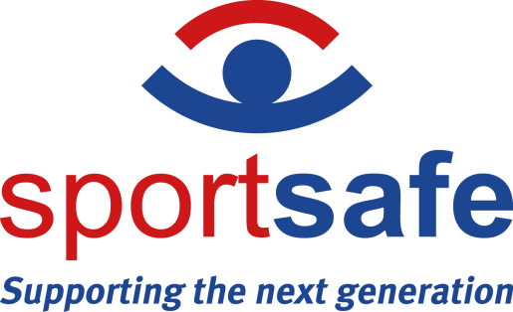

NEWS RELEASE 21st March 2024

Sportsafe Reduces Cable Repair Turnaround for Thousands of Education and Sports Clients
Sportsafe's recent acquisition of a cutting-edge swaging machine has sparked a transformation in our cable repair services, significantly slashing downtime for clients across education, fitness, and sports sectors.

Thanks to intensive training, three adept Sportsafe operatives are now proficient in a diverse range of cable repair and manufacturing tasks, all conducted in-house at our expansive 11,000sqft warehouse adjoining our Colchester headquarters. Given the critical role cables play in our extensive lineup of outdoor and indoor play, fitness, and sports equipment, this swift in-house service heralds a game-changer for our clientele nationwide.

Ensuring the absolute safety and quality of every repair remains our top priority. Ashley Stalley, Sportsafe's Warehouse Manager, underlines our commitment, stating, "The integrity and safety of our cables are non-negotiable, given their pivotal role in supporting equipment subjected to rigorous use. By sourcing parts from industry leaders, we ensure that only the finest materials are utilized in our repairs."

Each repair undergoes rigorous scrutiny, with a minimum of two technicians and a Sportsafe engineer conducting meticulous assessments before approving the product for client use. The efficiency and precision enabled by our state-of-the-art machine have exceeded expectations, elevating our ability to deliver superior service to our clientele.

In an industry where safety reigns supreme, Sportsafe remains unwavering in our dedication to upholding the highest standards of manufacturing processes and product safety. Our commitment to employing the latest engineering techniques ensures that every piece of equipment not only meets stringent quality benchmarks but also adheres to the highest safety protocols.

As Sportsafe is entrusted with keeping the nation's pupils, students, and athletes in motion, we recognize the gravity of our responsibility. With the addition of this cutting-edge equipment, we bolster our resources to better serve our clients while maintaining a focus on safety.

-ENDS-

Notes to Editors:

- Sportsafe serves over 10,000 clients in the UK, offering comprehensive services ranging from supply and installation to inspection and maintenance of sports, play, and fitness equipment. Our diverse clientele includes private schools, sports centers, care homes, and over 100 county councils, as well as fire, police, and NHS authorities.
- With a nationwide network of offices and engineer hubs, Sportsafe ensures prompt service delivery, with our team never more than 90 minutes away from any client location. Our team comprises over 30 skilled engineers and inspectors, guaranteeing that only Sportsafe personnel handle the inspection and maintenance of our clients' equipment.
- Sportsafe UK holds esteemed health and safety accreditations, including CHAS, Constructionline Gold, and Alcumus SafeContractor. Additionally, we are proud members of AFPE, providing our clients with the assurance that their equipment is in capable hands.
- As pioneers in our industry, Sportsafe is the first company to achieve ISO 45001:2018 accreditation, underscoring our commitment to operational excellence and client satisfaction. Our ISO 14001:2015 accreditation underscores our dedication to minimizing our environmental footprint, while adherence to the ISO 9001:2015 standard ensures the delivery of efficient and organized services to our valued customers.

- For interviews and photo opportunities, please contact the marketing team on 01206 795265, marketing@sportsafeuk.com

