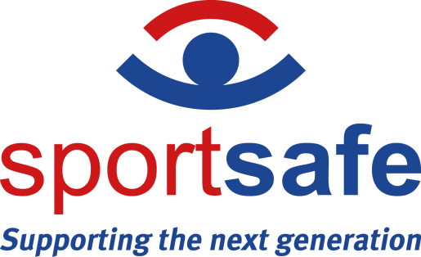

NEWS RELEASE 25th August 2023

Jakarta FIBA Basketball World Cup
Supported by Schelde Sports Working with Sportsafe Engineering Team

Here in Jakarta, the atmosphere is electric as teams from Iran, Brazil, Canada, Latvia, Lebanon, France, Cote D’Ivoire, as well as 2019 World Cup winners, Spain, gear up for the start of the FIBA Basketball World Cup today.
In total, 32 teams will play 92 games across 16 days in the Philippines, Japan and Indonesia and Sportsafe is thrilled to have two of their Colchester-based engineers out here in Jakarta to support the Schelde Sports technical team.
“The FIBA World Cup is the pinnacle of the Basketball calendar for players and fans alike,” says Claire Hunt, Sportsafe UK Sales & Marketing Director. “We could not be prouder of our engineers and the support they are giving the Schelde Sports technical team in Jakarta. We know that with them working behind the scenes to install, maintain and service key sports equipment, the world-class players can focus fully on the game and their performance in optimum conditions.”
Interest in Basketball is strong in Indonesia, especially after hosting the FIBA Asia Cup in 2022. The Sportsafe engineers have joined the Schelde Sports technical team in the brand new, 16,000-capacity Indonesia Arena, Lapangan Banteng, Jakarta, which is based on a green building concept celebrating community and diversity specifically designed for the FIBA Basketball World Cup 2023.
Sportsafe Basketball installations and services already provided in the UK include electric scoreboards, bespoke roof-mounted and wall-mounted match goals, practice goal sets, new and refurbished sports hall flooring, games line provision, multiple-game division netting design, roof protection nets, and safety maintenance, inspection and repair.

– ENDS –
Notes to editors
- Sportsafe offers supply, installation, inspection and maintenance of sports, play and fitness equipment to more than 10,000 customers in the UK, including private schools, sports centres, care homes and more than 100 county councils and fire, police and NHS authorities.
- Sportsafe has a nationwide network of offices and engineer hubs keeping them within 90 minutes of their clients. The company employs over 30 Engineers and Inspectors, and they guarantee that only Sportsafe staff will inspect and maintain their clients’ sports equipment.
- Sportsafe UK holds CHAS, Constructionline Gold and Alcumus SafeContractor health and safety accreditation, and they are also a member of AFPE and ROSPA, giving their customers peace of mind that their equipment is in safe hands.
- Sportsafe is the first company in its industry to have ISO 45001:2018 accreditation, which further endorses our commitment to always meeting the highest standards of operation for the benefit of both employees and clients. Its ISO 14001:2015 accreditation emphasises the company’s commitment to improving our impact on the environment and the effectiveness of the controls and measures it has in place. Working to the ISO 9001:2015 standard means that the business has implemented solid and efficient processes that ensure it provides effective and well-organised services to its customers.

- For interviews and photo opportunities, please contact the marketing team on 01206 795265, marketing@sportsafeuk.com

