Leap for Good – Sportsafe employees raise over £2,500 for St Helena Hospice
‘One good turn deserves another’ took on a whole new meaning recently when four Sportsafe colleagues - so inspired by the work done at St Helena’s Hospice – chose to face their fears and leap out of a small plane on a skydiving fundraising challenge in memory of their friend and workmate, Sue Beckett. Their efforts raised over £2500 for the hospice.
The St Helena Hospice website has two core areas – ‘How we can help you’ and ‘How you can help us’ – reflecting exactly the thoughts of Anna Greenwood, Lauren Heasman, Karen Robinson and Alex Wilkins when they were considering the jump.
The challenge was sparked by Karen seeing the St Helena Hospice initiative to ‘Skydive for Charity’ and everyone wanting to do something in memory of Sue, who loved getting involved in events like this herself and raising money for charity.
“Sue would have been the first to sign up for the skydive,” says Karen. “We all knew this was very fitting to her memory. Also, St Helena is it is very close to my heart as I have close friends who used St Helena Hospice. It was good to keep their memory alive as well.”
Lauren adds, “My family and I had the help and support from the charity through an incredibly tough time so I have experienced the amazing and compassionate work that they do. When I heard that the Skydive was to raise money for them, I wanted to be involved to raise as much as we could so that they can continue to provide the same support for others.”
St Helena Hospice helps local people who are facing incurable illness and bereavement, providing support for family members and friends and empowering everyone to plan ahead, share their choices and to benefit from the best possible support and compassion at the most difficult of times.
“The equivalent of seven out of ten of the patients and families cared for are funded by others getting involved in fundraising activities, buying from the shop, gifts through Wills, and taking part in the Lottery,” says St Helena Hospice fundraiser, Lisa Chenery. “We are so grateful to Sportsafe’s Anna, Karen, Lauren and Alex for their courageous leap of faith to raise so much in support of the patients and families at the heart of St Helena’s Hospice. They really were very brave!”
The chain of inspiration continues as Lauren also comments, “I would 100% do it again and would recommend anyone to give it a go – especially if it’s going to mentally challenge you. Huge kudos to our little team and I’m super proud of us for raising such an amazing amount of money and I’m sure Sue would be too!”
Donations to St Helena Hospice can be made direct at https://www.sthelena.org.uk/how-you-can-help-us/donate/make-a-difference or to find out more information about the support provided please see https://www.sthelena.org.uk/how-you-can-help-us/donate/make-a-difference.
– ENDS –
Notes to editors
- Sportsafe offers supply, installation, inspection and maintenance of sports, play and fitness equipment to more than 10,000 customers in the UK, including private schools, sports centres, care homes and more than 100 county councils and fire, police and NHS authorities.
- Sportsafe has a nationwide network of offices and engineer hubs keeping them within 90 minutes of their clients. The company employs over 30 Engineers and Inspectors, and they guarantee that only Sportsafe staff will inspect and maintain their clients’ sports equipment.
- Sportsafe UK holds CHAS, Constructionline Gold and Alcumus SafeContractor health and safety accreditation, and they are also a member of AFPE and ROSPA, giving their customers peace of mind that their equipment is in safe hands.
- For interviews and photo opportunities, please contact the marketing team on 01206 795265, marketing@sportsafeuk.com
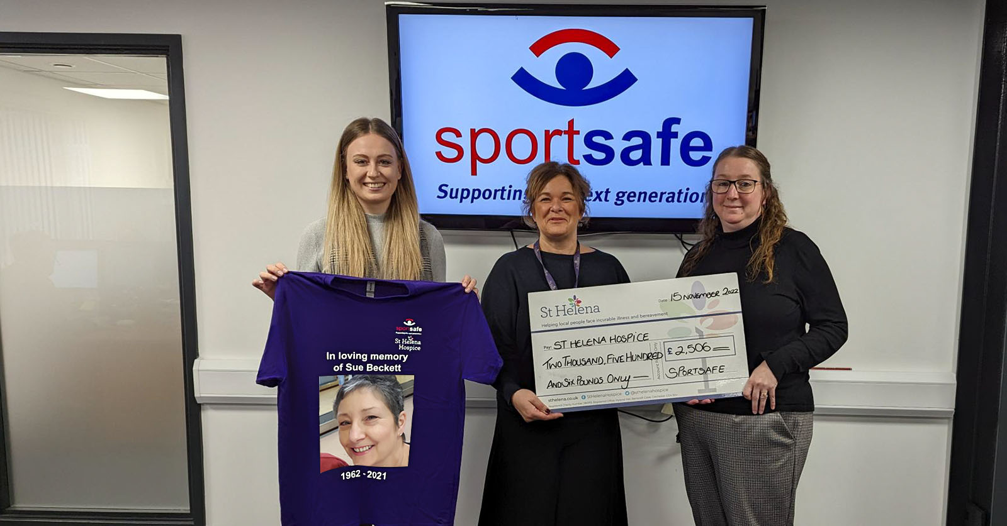
From left to right: Lauren Heasman (Outdoor Project Estimator at Sportsafe), Lisa Chenery (Fundraiser at St Helena Hospice), Anna Greenwood (Head of Finance, Supply Chain, IT & Property at Sportsafe).

