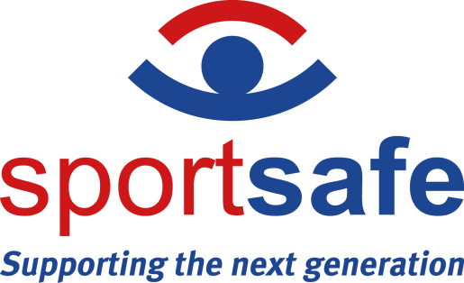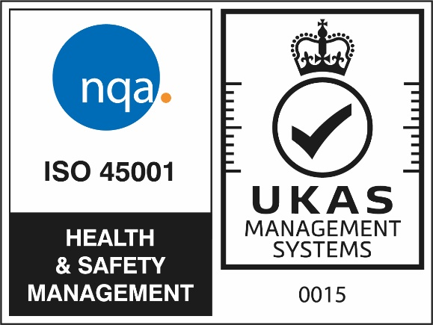

NEWS RELEASE 27th October 2022
Sportsafe – Colchester HQ announces first in industry ISO accreditation
Sportsafe’s Colchester HQ is delighted to announce that the company is the first in its industry to be awarded the globally recognised Health & Safety accreditation ISO 45001:2018. As leading health and safety inspectors of sports equipment, this certification further endorses the Sportsafe commitment to always meeting the highest standards of operation for the benefit of both employees and clients.
“We are so proud of all our staff for their commitment to Sportsafe and their intrinsic desire to work consistently to the very highest standards,” says Sales & Marketing Director, Claire Hunt. “We have dynamic, engaged and informed teams working within professional, safe, and efficient environments. The leadership team strives to create an inclusive culture to ensure everyone feels safe and supported and to provide a healthy, engaging and positive work environment. We are delighted to be the first in our industry to have achieved this key ISO recognition – credit to each and every person at Sportsafe.”
ISO 45001:2018 is applicable to any organization that wishes to establish, implement, and maintain a management system to improve occupational health and safety, eliminate hazards and minimize risks. It is a global standard for occupational safety and health management systems, giving practical solutions for worker health and safety whilst promoting and protecting physical and mental health. At least 70 countries contributed to the drafting process to create ISO 45001 standards, helping organisations to demonstrate their serious internal and external commitment to workplace safety and to reinforce their commitment to, and reputation with, staff and customers.
Alongside being the first in the industry to achieve ISO 45001, Sportsafe has also just received ISO 9001 and 14001 recertification following a comprehensive audit.
– ENDS –
Notes to editors
- Sportsafe offers supply, installation, inspection and maintenance of sports, play and fitness equipment to more than 10,000 customers in the UK, including private schools, sports centres, care homes and more than 100 county councils and fire, police and NHS authorities.
- Sportsafe has a nationwide network of offices and engineer hubs keeping them within 90 minutes of their clients. The company employs over 30 Engineers and Inspectors, and they guarantee that only Sportsafe staff will inspect and maintain their clients’ sports equipment.
- Sportsafe UK holds CHAS, Constructionline Gold and Alcumus SafeContractor health and safety accreditation, and they are also a member of AFPE and ROSPA, giving their customers peace of mind that their equipment is in safe hands.
- For interviews and photo opportunities, please contact the marketing team on 01206 795265, marketing@sportsafeuk.com

