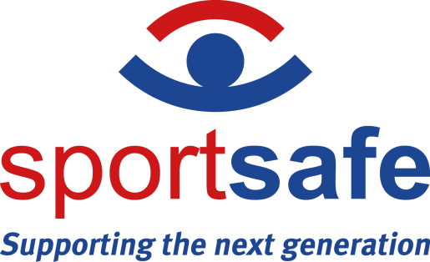

NEWS RELEASE 19th July 2022

Sportsafe officially opens its new Colchester headquarters

Sportsafe is pleased to announce that all its head office teams have moved to its new headquarters. The company has invested in the new head office and warehouse to provide its staff with a clean, secure, and engaging environment. These are newer, larger premises of over 11,000 sq. feet, with the addition of a secured storage yard for Sportsafe’s outdoor products.
A few words about Sportsafe’s new warehouse.
- 30% increase in capacity for palletised goods.
- Picking and packaging area for consumables.
- Dedicated counter for the collection of parts.
- Dedicated workshops for making our trampoline mat sets.
The company chose to vacate its previous premises at Moorside, which were circa 60 years old, as it was no longer big enough for the company's year growth strategy and a dated working environment for the team.
After months of strategic planning, Sportsafe chose the popular Severalls Industrial Park as the location for its new headquarters. This prime industrial estate in Colchester offers good access to both J28 (Northern Gateway) and Junction 29 (Ipswich Road) of the A12, allowing Sportsafe to reduce the average travelling time to customer sites for its engineers and delivery drivers.
The new premises will further improve Sportsafe’s operations by expanding its warehousing capacity, enabling more stock to be kept on site. This will aid the distribution of the sports and fitness equipment parts to engineer teams nationwide, further improving the company’s logistics and reducing its environmental impact with fewer external deliveries.
The new offices also offer Sportsafe the opportunity to create an environment that helps bring its teams together with a large open space and dedicated areas for each team over two floors. The building was designed and built with environmental awareness and energy efficiency in mind to further support its ISO 14001 accreditation, and out of a desire to create a modern, dynamic, and safe working environment in which all Sportsafe employees can thrive.
The company has installed air conditioning and air filters in its new offices, using the latest Nanoe X technology to filter out pollution, viruses, and bacteria, all while keeping the office space clean.
Since 2019, Sportsafe has gone from strength to strength, even throughout the COVID-19 pandemic to become the leader within its field in the UK and is now at the forefront of the sports equipment inspection industry.
Sportsafe Head of Finance, Supply Chain, IT & Property, Anna Greenwood says, “Fully completed in June 2022, our new Colchester head office and warehouse are the future of Sportsafe. We are now set up for sustainable growth over the next ten years, offering employment opportunities to the local workforce.”
– ENDS –
Notes to editors
- Sportsafe offers supply, installation, inspection and maintenance of sports, play and fitness equipment to more than 10,000 customers in the UK, including private schools, sports centres, care homes and more than 100 county councils and fire, police and NHS authorities.
- Sportsafe has a nationwide network of offices and engineer hubs keeping them within 90 minutes of their clients. The company employs over 30 Engineers and Inspectors, and they guarantee that only Sportsafe staff will inspect and maintain their clients’ sports equipment.
- Sportsafe UK holds CHAS, Constructionline Gold and Alcumus SafeContractor health and safety accreditation, and they are also a member of AFPE and ROSPA, giving their customers peace of mind that their equipment is in safe hands.
- For interviews and photo opportunities, please contact the marketing team on 01206 795265, marketing@sportsafeuk.com

